AIF Fund I - Only FUND I (in bold)

2nd tab should be Fund Details instead of Fund I

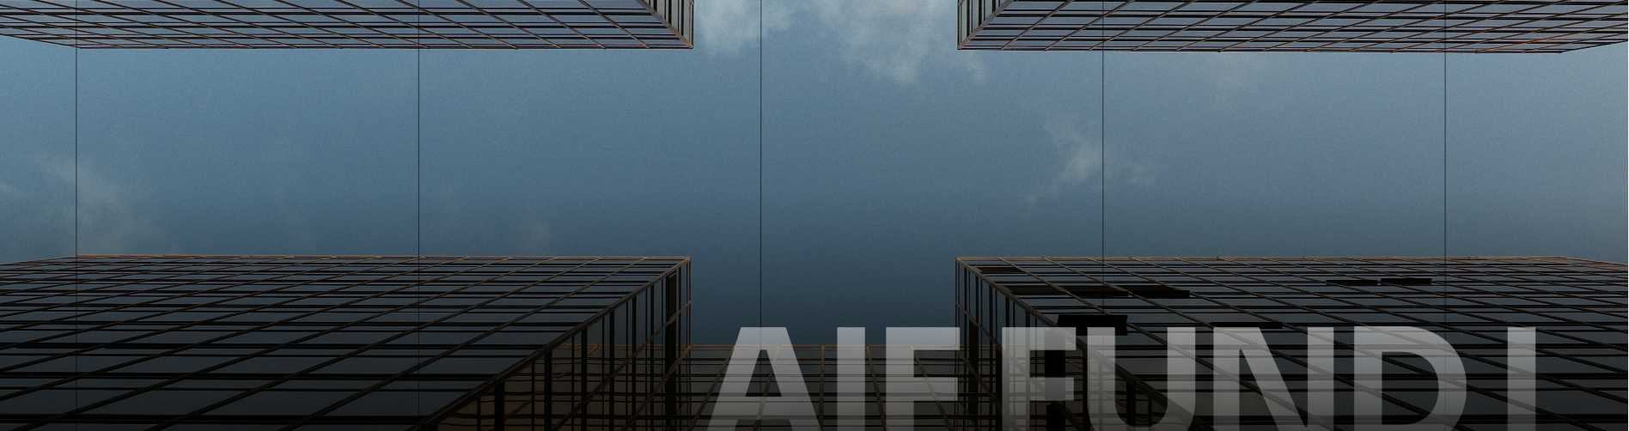
Investing in India’s Industrial Growth

Value. Vision. Wealth. – Remove

// An Integrated Industrial Infrastructure Platform - An Integrated Fund & Industrial Development Platform

Capital and operating capability, aligned across the industrial infrastructure lifecycle. KSH INFRA combines capital management, development, leasing and property management to create and manage Grade A industrial and logistics assets through one integrated platform.
-
Capital and operating capability, aligned across the industrial infrastructure lifecycle. KSH INFRA combines fund management, investments, development, leasing and asset management capabilities to build and manage Grade A industrial and logistics parks through one integrated platform — from opportunity assessment to asset stabilisation and realisation.

Investment performance begins before capital is deployed and continues long after construction is complete. Our teams bring investment, land, development, leasing and operational perspectives into a connected process — from opportunity assessment to asset stabilisation and realisation. – Remove

Invest. Develop. Lease. Operate. Realise – Investment Lifecycle

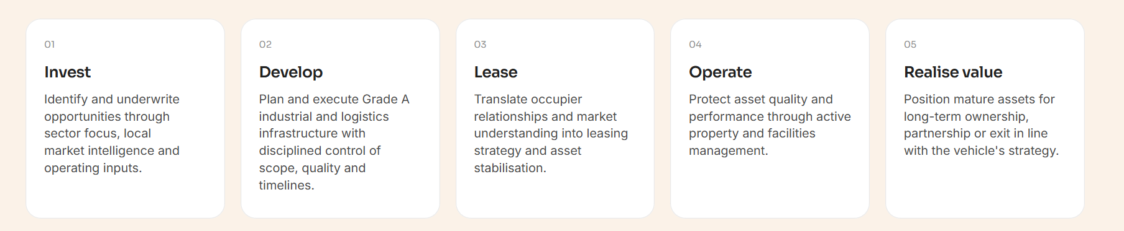
Remove 01, 02 … & make the graphic different to look like a flow

Invest - Identify and underwrite opportunities through sector focus, local market intelligence and operating inputs.
-
Invest - Identify and underwrite opportunities through geographical focus, local market intelligence and on ground inputs through development team.

Develop - Plan and execute Grade A industrial and logistics infrastructure with disciplined control of scope, quality and timelines.
-
Develop - Plan and build Grade A industrial and logistics infrastructure with disciplined execution and control of cost, quality and timelines.

Lease - Translate occupier relationships and market understanding into leasing strategy and asset stabilisation.
-
Lease - Translate market understanding and client relationships to deliver best in class customised grade A industrial facilities.

Operate - Protect asset quality and performance through active property and facilities management.
-
Operate – Create exceptional occupier experiences while delivering sustainable operations through relentless focus on facilities management and long term value creation.

Realise value - Position mature assets for long-term ownership, partnership or exit in line with the vehicle's strategy.
-
Realise value - Position mature assets for long-term ownership, partnership or exit in line with the fund's strategy.

Delete this part from Overview and shift to Fund I
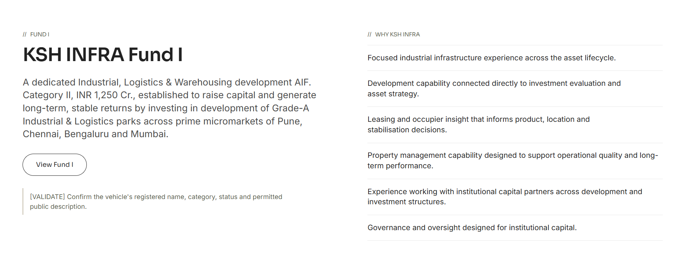
Our Investors
-
Strategic partners in past projects

Delete as discussed
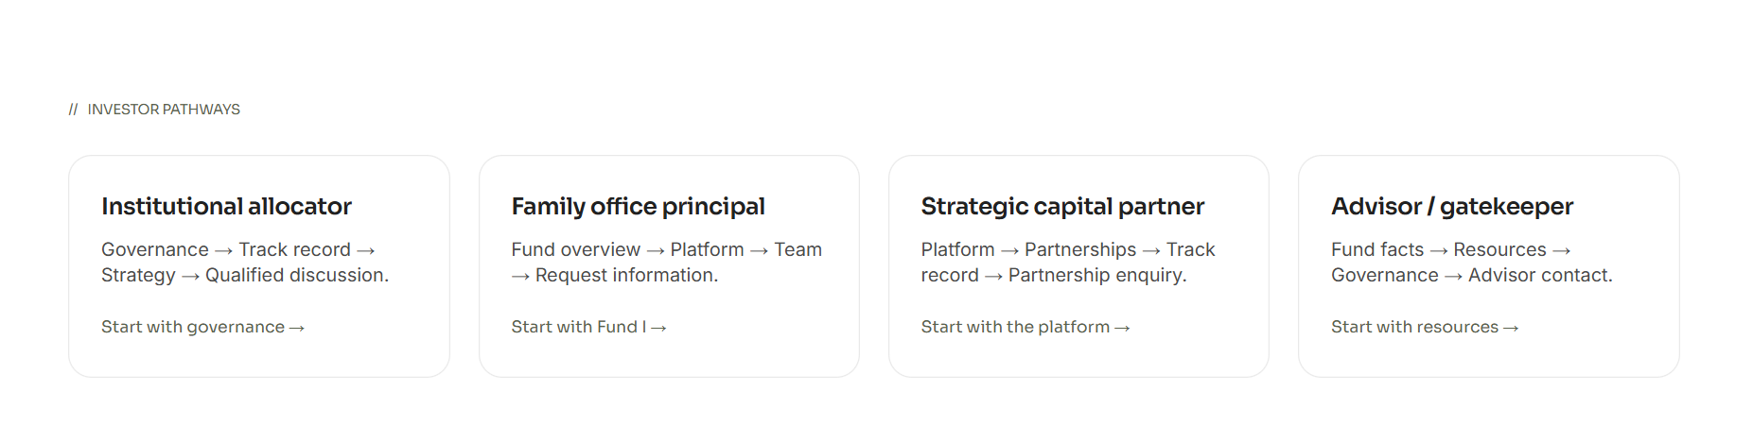

Please delete the below as discussed and redirect to the main website query form, where by default the persona selected should be ‘investor’.

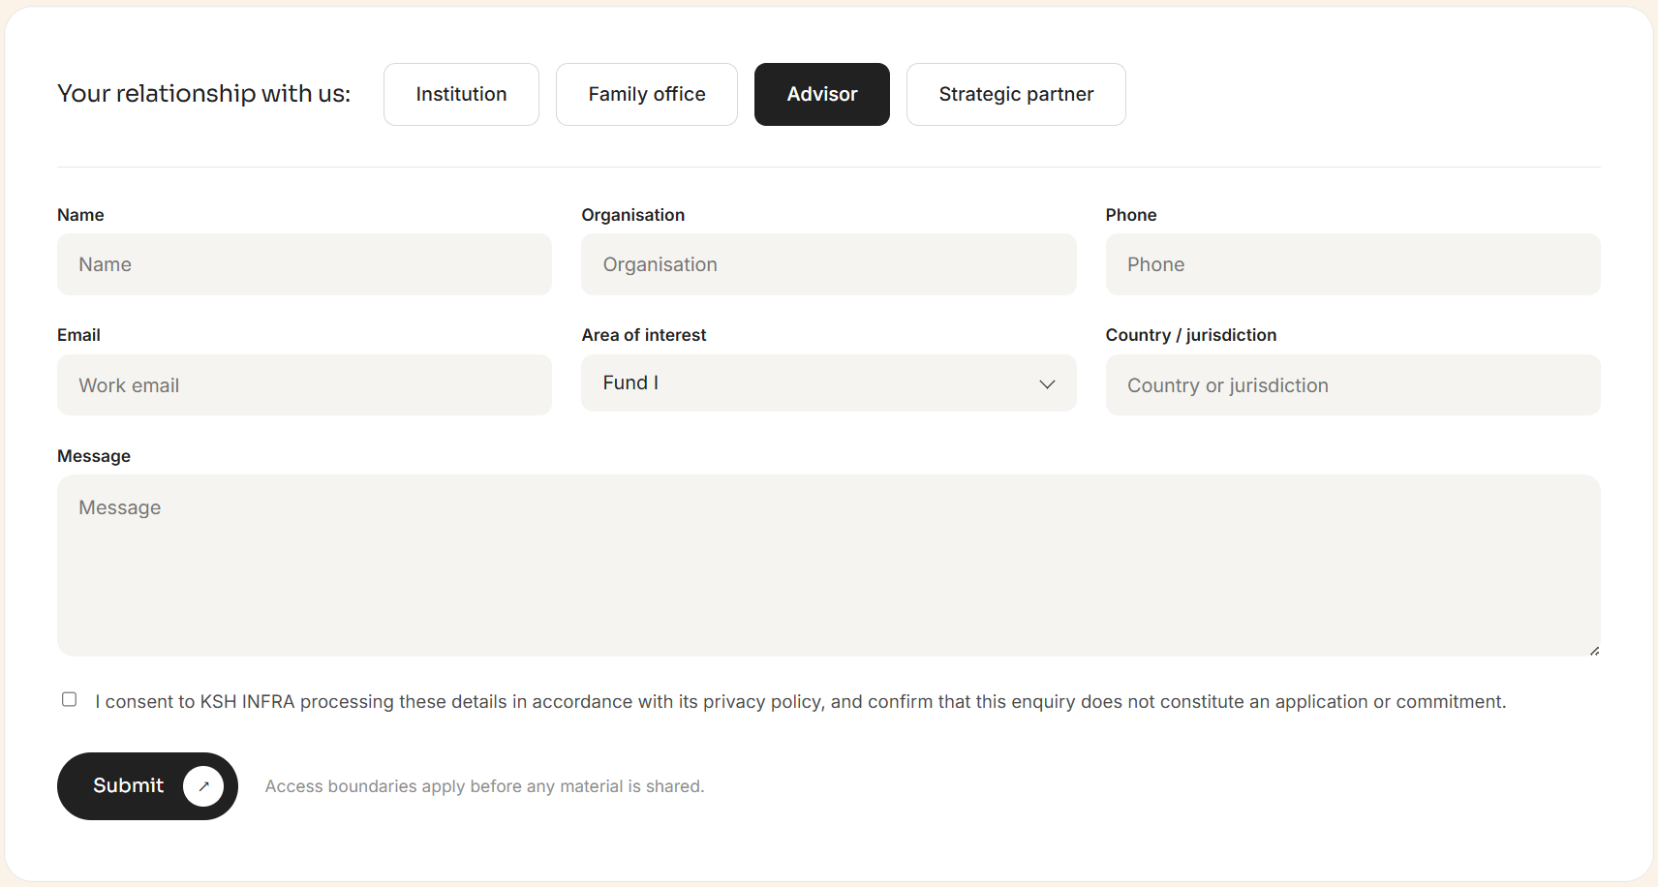

CIN No: U66300PN2024PTC229079
SEBI registration: IN/AIF2/26-27/2209

Addresses :

KSH INFRA,
INNOV8, 8th Floor, Tower B,
Peninsula Business Park,
Lower Parel (W), Mumbai – 400013

KSH INFRA,
461 2 Sadashiv Peth, Tilak Road,
Pune 411030, Maharashtra, India

- Should have Mumbai address 1st and then Pune address

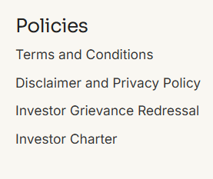

Disclaimer and privacy Policy – Should be 2 separate links 1 after the other
Nothing on this website constitutes an offer, solicitation or recommendation to invest in the fund. Access and participation are subject to eligibility, documentation and applicable law. Draft content pending business, legal and compliance review. – Remove yellow highlighted & add blue highlighted

Fund I to be renamed to Fund Details

A Category II AIF established to raise capital and generate long-term, stable returns by investing in development of Grade-A Industrial & Logistics parks across prime micromarkets of Pune, Chennai, Bengaluru and Mumbai.
-
A Category II AIF with a target corpus of INR 1,250 Cr, established to generate stable returns by investing in development of Grade-A Industrial & Logistics parks across industrial ecosystems around Pune, Chennai, Bengaluru and Mumbai.

Add shailesh’s photo and quote mentioning him as Fund Manager.

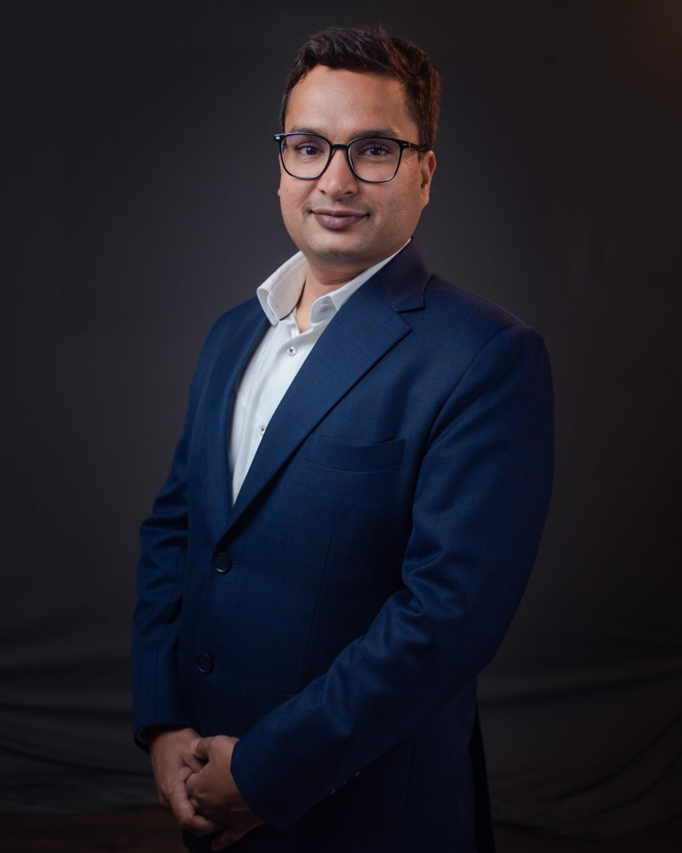

https://www.linkedin.com/posts/ksh-infra_kshinfra-industrialgrowth-logistics-activity-7457610096034975744-fT_D?utm_source=share&utm_medium=member_ios&rcm=ACoAAAFwjvsB3vnxrfHPE2QYT3Tv38bkMmyeyMs

Add a “Key Highlights” section

- Exposure to India’s high growth industrial, logistics & warehousing sector​, driven by consumption and manufacturing led demand
- Backed by an established sponsor with experienced leadership team & proven track record across investment cycle (7 Mn Sqft) across 10+ years
- Precedence of delivering >23% IRR across marquee institutional partnerships
- INR 1,250 Cr fund with skin in the game (10%) having a focused investment strategy with 6-8 investments across 5.5 year tenure
- High quality pre-identified assets & visible development pipeline ​

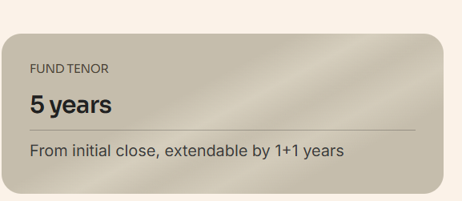

Change to 5.5 years
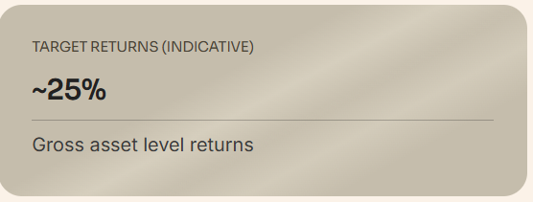

TARGET RETURNS (INDICATIVE – NOT ASSURED)

~25% IRR (Gross asset level)
~1.80 MOIC

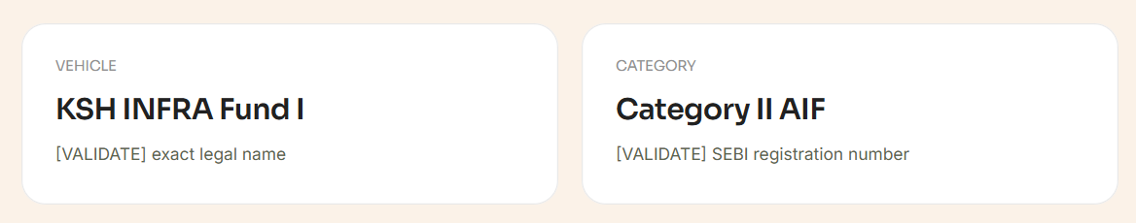

Vehicle : KSH INFRA Industrial, Logistics and Warehousing AIF

SEBI Registration Number : IN/AIF2/26-27/2209

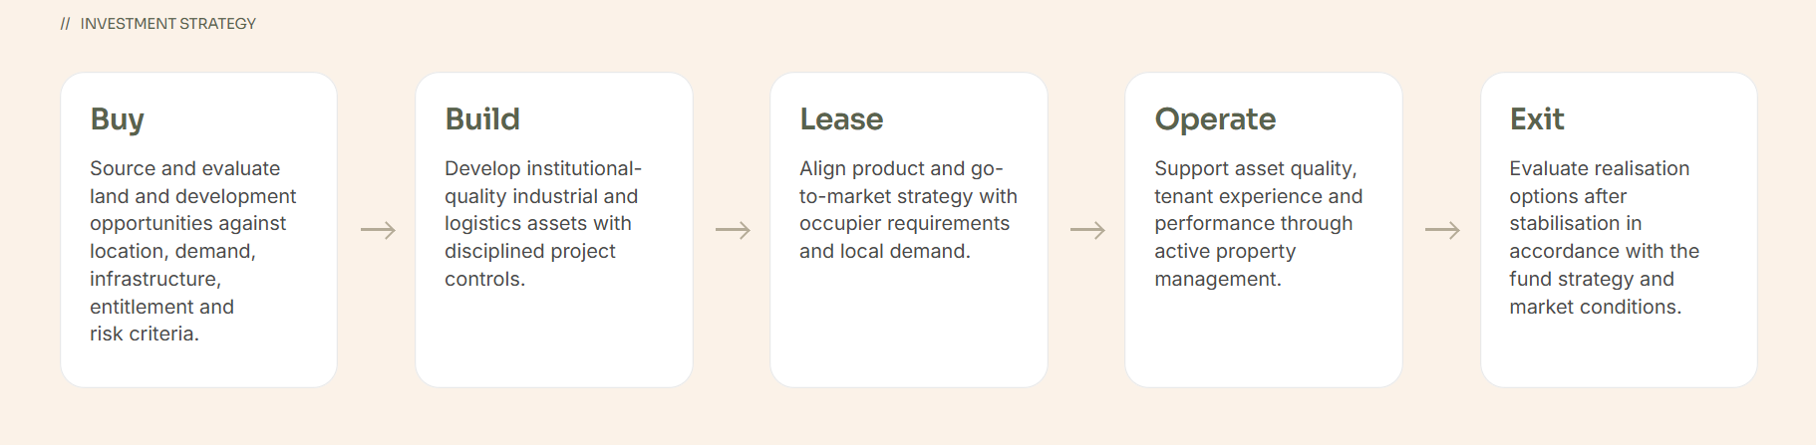

Duplicate same as one made in overview

Investment criteria

- Grade A industrial and logistics infrastructure.
- Priority markets approved within the fund mandate.
- Sites with credible access, infrastructure, entitlement and development pathways.
- Demand supported by manufacturing, logistics or supply-chain activity.
- Opportunities where KSH INFRA's development and operating capabilities can materially contribute.
- Risk and return characteristics consistent with the fund's formal documents.

-Remove full stops after every bullet points

Remove these 2 tabs
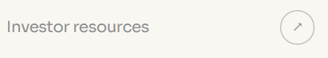
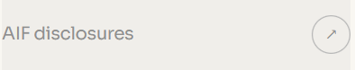

Governance

Remove below

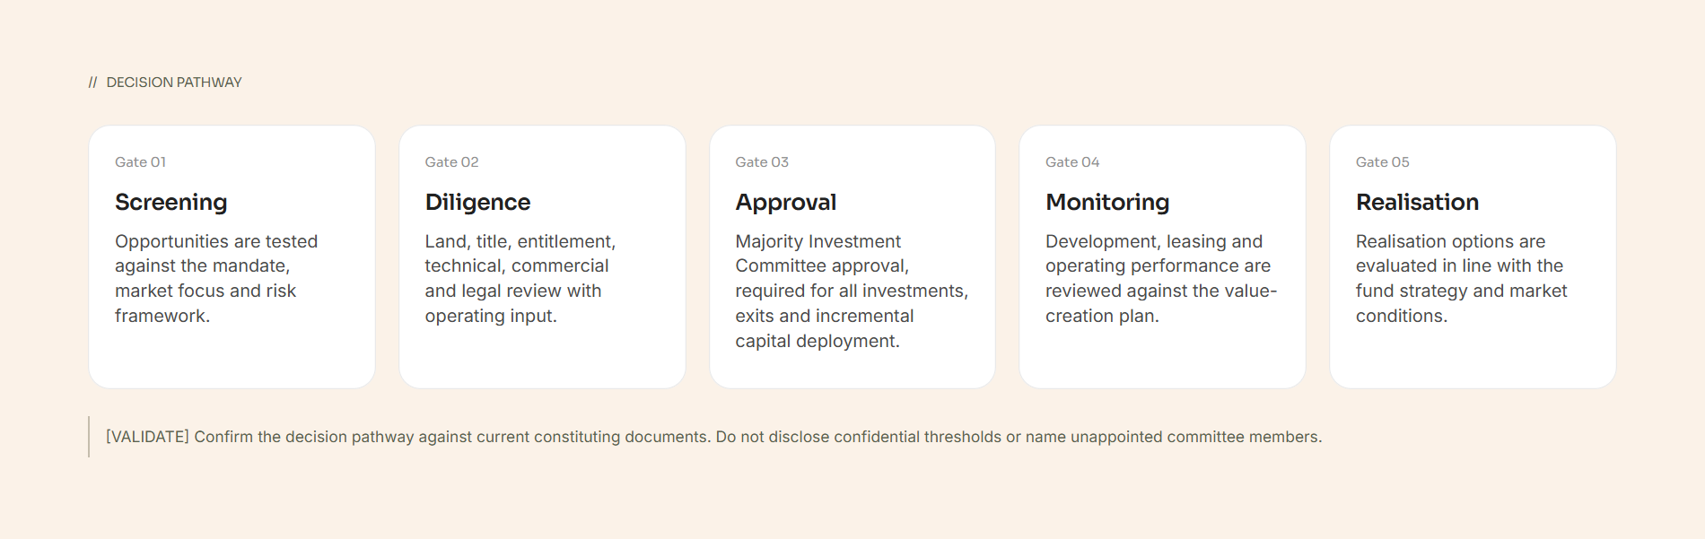

Remove below too

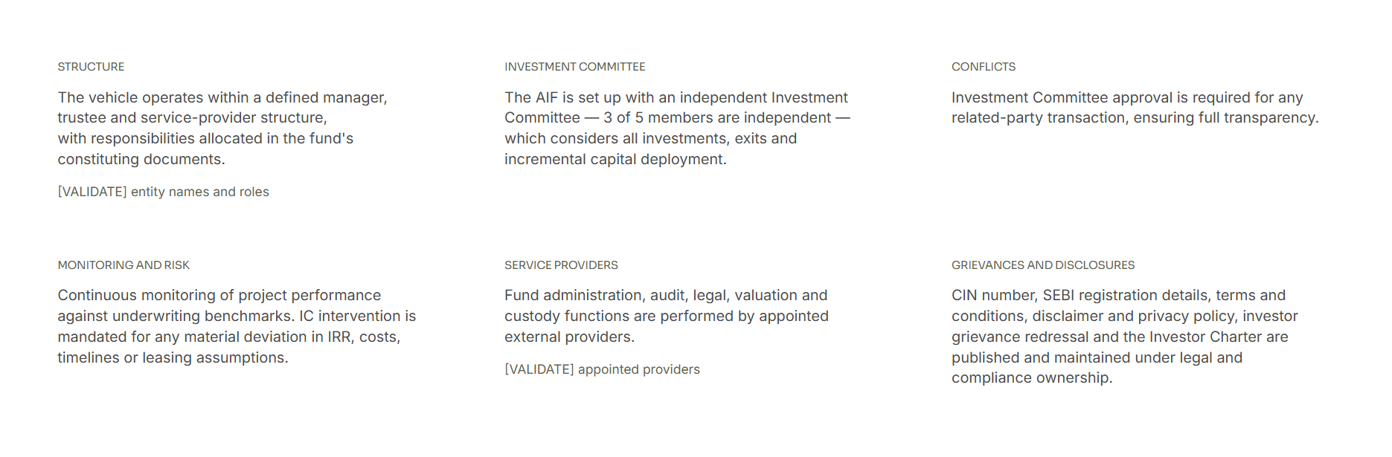
Remove full stops from all below texts

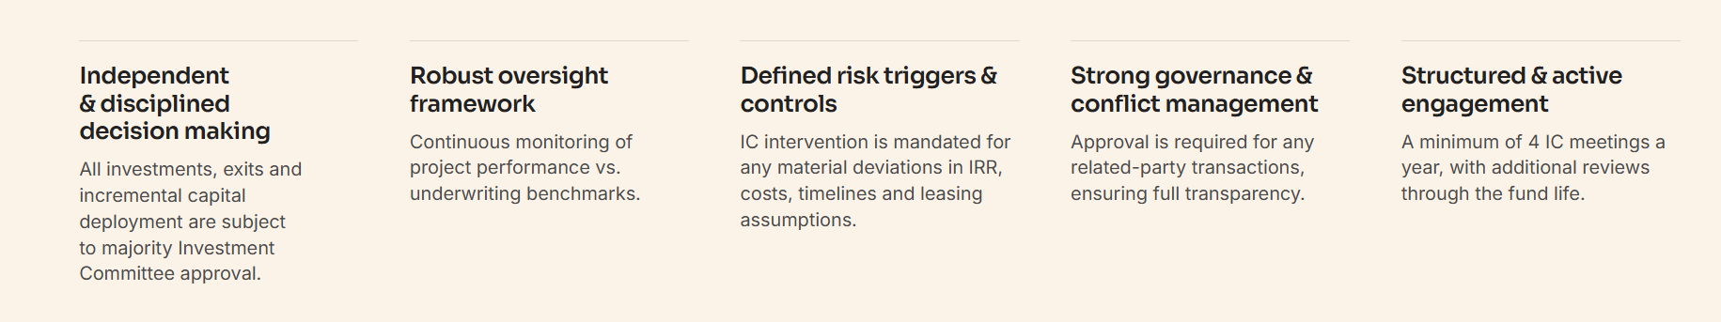

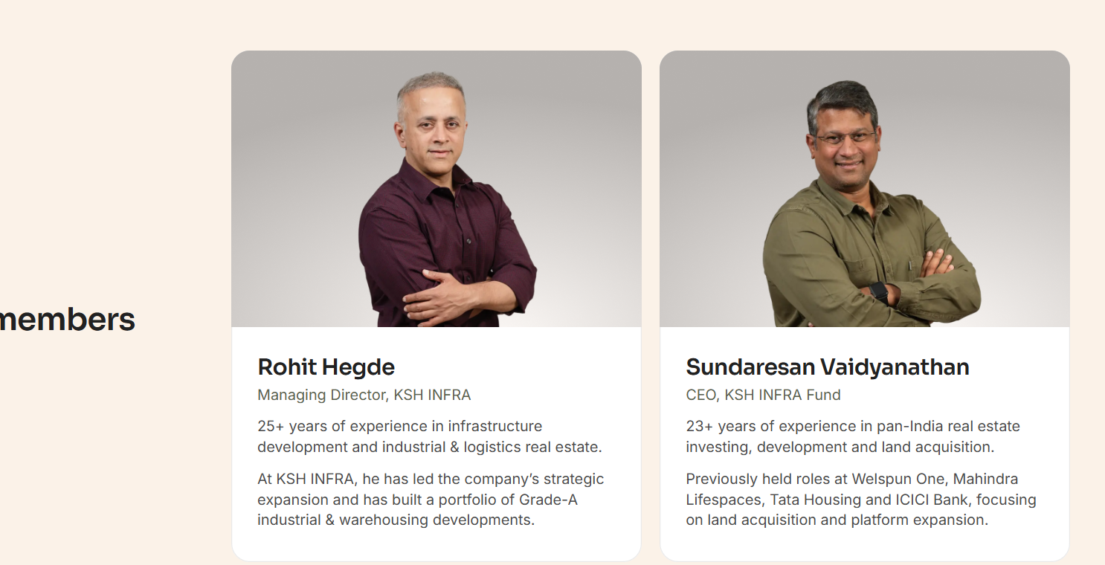

Can we create pop ups of text on the image. For example, check below website.

https://onzawealth.com/about

Delete below :
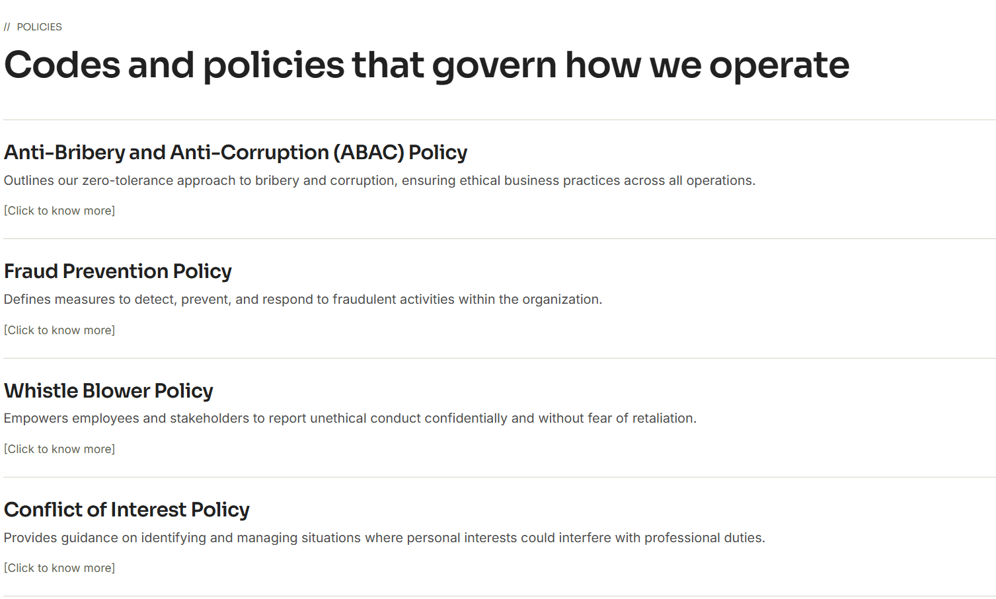

Merge Integrated Platform Page into Overview

Delete
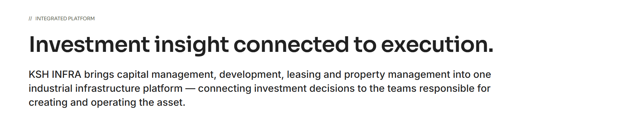

Move to Overview page after The lifecycle section
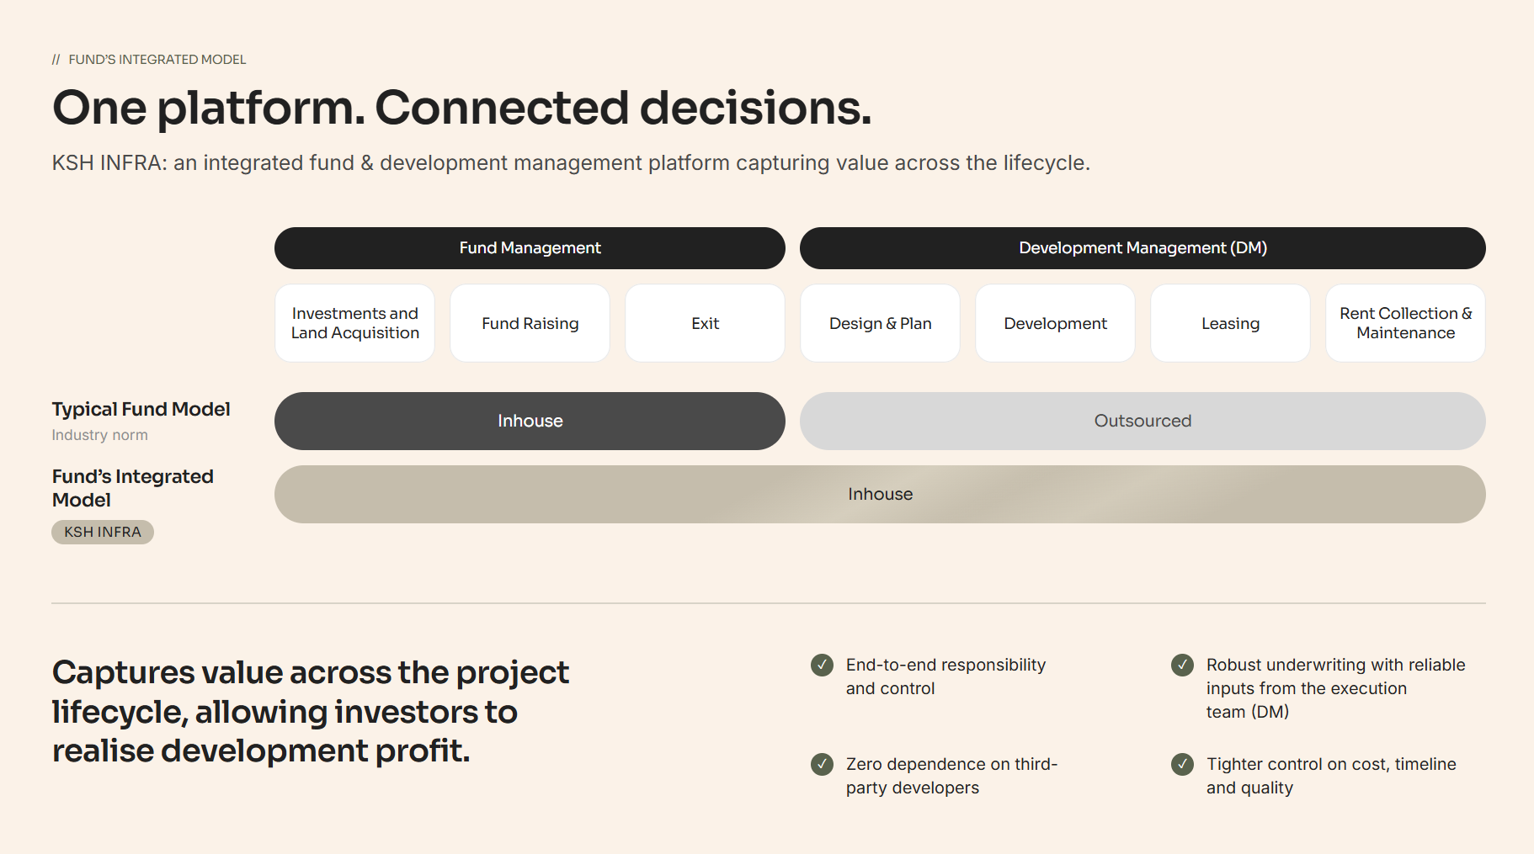

Changes :

Under Fund Management:
Fund Raise >> Investments and Land Acquisition >> Asset Management and Exits

Move to Overview page after the above mentioned section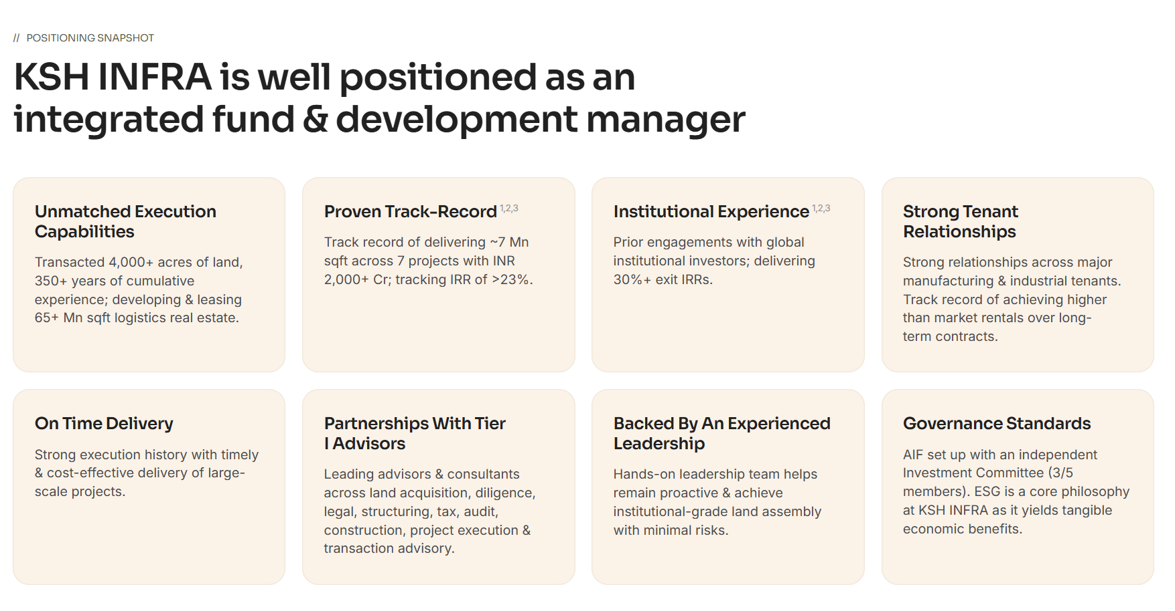
Changes : - Remove full stops from everywhere

Proven Track-Record – Remove superscript 1,2,3
Track record of delivering ~7 Mn sqft across 7 projects with INR 2,000+ Cr; tracking IRR of >23%. - Remove

Institutional Experience^{1,2,3}
Prior engagements with global institutional investors; delivering 30%+ exit IRRs.
- Strategic partnerships with marquee global institutional investors delivering 25%+ IRRs

Governance Standards
AIF set up with an independent Investment Committee (3/5 members). ESG is a core philosophy at KSH INFRA as it yields tangible economic benefits.
-
ESG compliant investments with ESG being a core philosophy at KSH INFRA
AIF set up with an independent Investment Committee (3/5 members) [2 separate points in 2 different lines]

Merge Track Record under Overview

Delete below
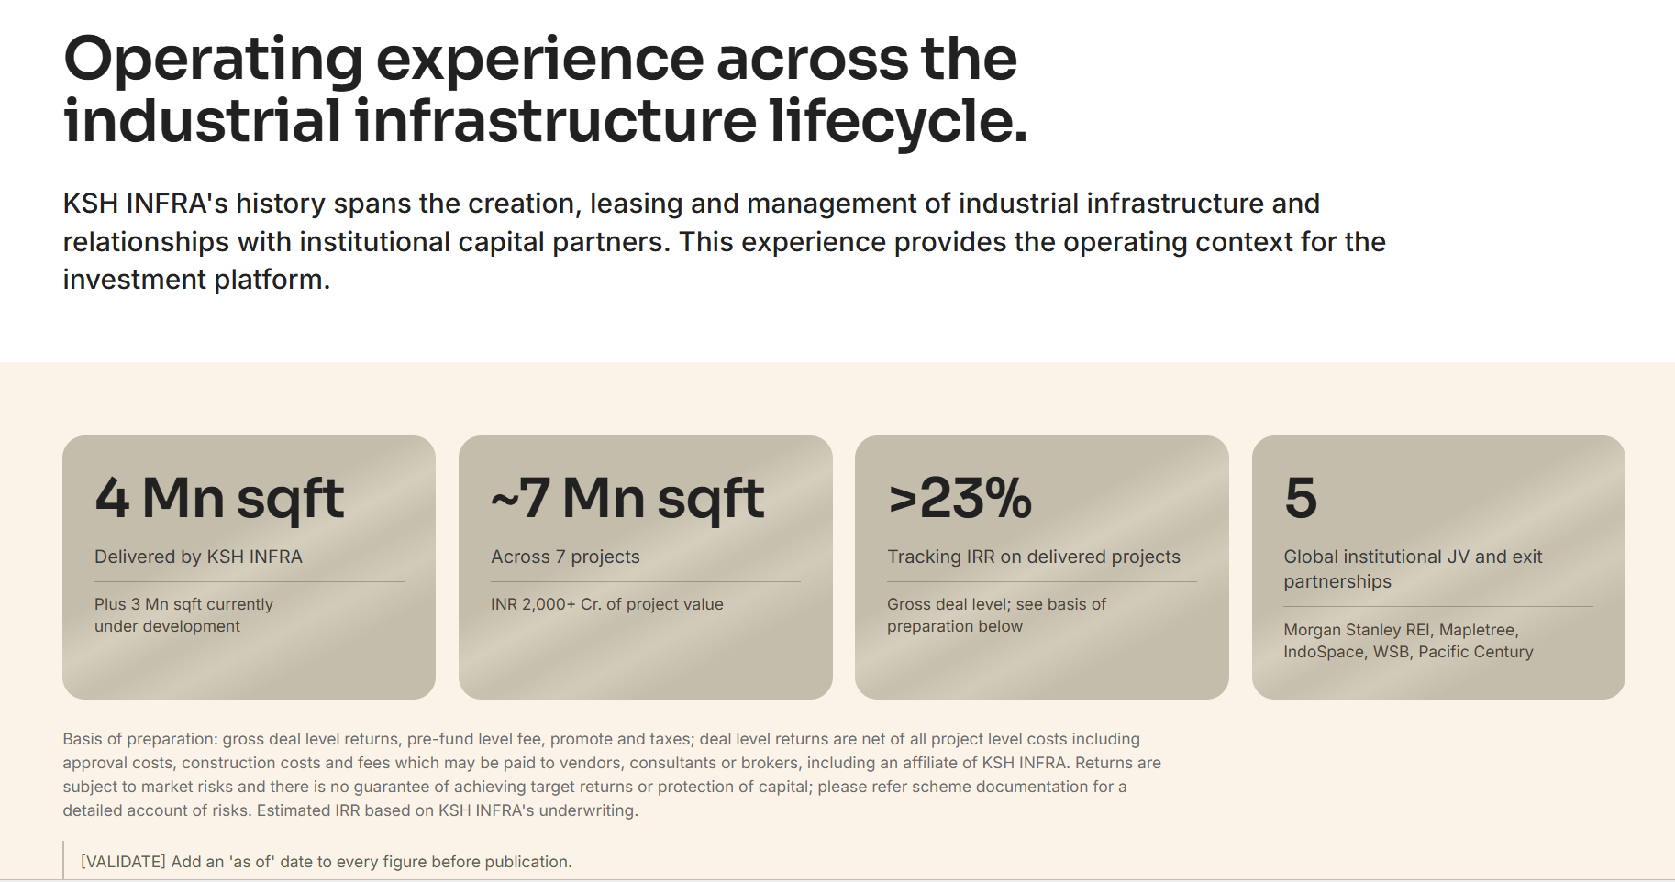

Replace Institutional Investors in Overview with below

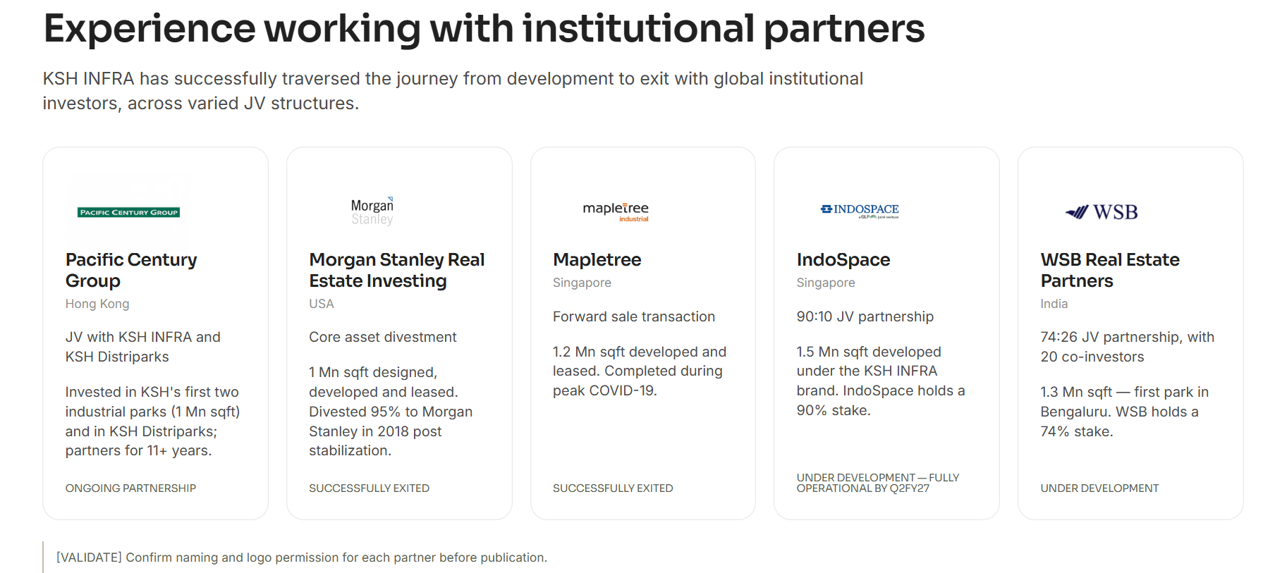

Pacific Century Group

Strategic Long Term JV
Invested in KSH's first two industrial parks (1 Mn sqft)
11+ years partnership with 23% exit IRR
Long Term partnership
Morgan Stanley Real Estate Investing
Core asset divestment
Divested 95% of 1Mn sqft park to Morgan Stanley in 2018
Operated the park for more than 2 years with 30% IRR at exits
Successfully exited

Maple Tree- Keep it as it is

IndoSpace
90:10 JV partnership
1.5 Mn sqft developed and leased under the KSH INFRA brand
Expected IRR of >30%
Fully operational

WSB Real Estate Partners
74:26 JV partnership, with 19 co-investors
1.3 Mn sqft in Hosur near Bengaluru
Under development

Remove Below


